# ***Challenge Name :- Shorthand Sleuth***

**Description :** Analyze the PHP code to determine the purpose and usage of the text parameter shorthand notation, uncovering its potential implications.

**Level:** Easy

**Solution:**

**Step 1** : After connecting to the challenge, I found a PHP code that describes the presence of a text parameter. In order to obtain the flag, one must correctly input the value of the parameter.

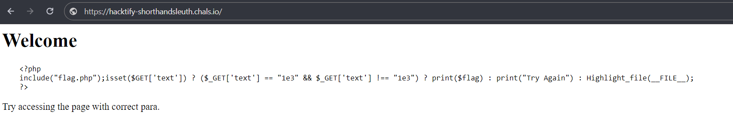

**Step 2** : <http://159.65.116.234:8087/?text=1e3>  
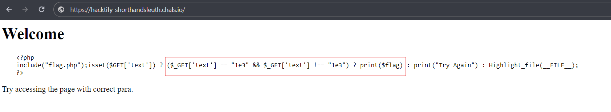  
it returned Try Again

Consequently, I opted to delve into the significance of the text parameter value by conducting a Google search to understand what 1e3 signifies, as depicted in the subsequent image.

**Step 4** : input a value of 1000 in decimal format as the textparameter, and the flag was successfully displayed.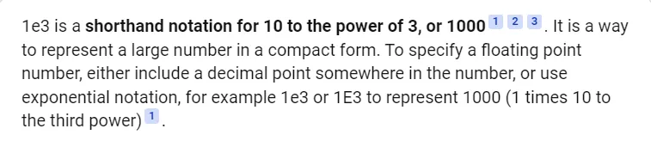

[http://159.65.116.234:8087/?text=1000](http://159.65.116.234:8087/?text=1000*)

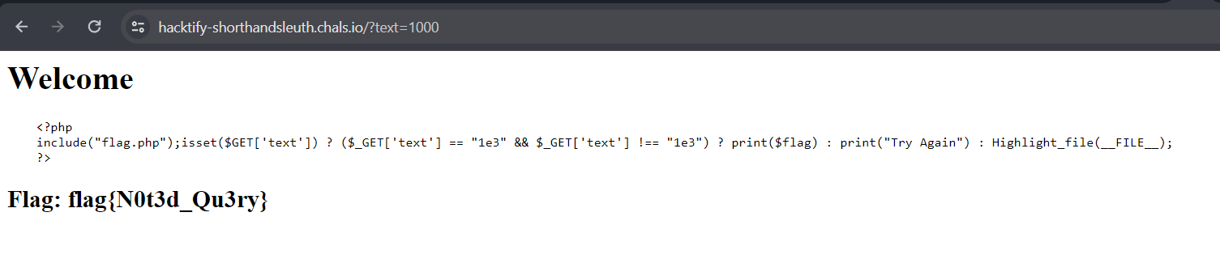

Hence the flag is:- flag{N0t3d_Qu3ry}

This page is intentionally left blank